**STEP 1:** To select the user stories you want on the task board, 1st press the three dots to open a drop down menu, then click on select all.

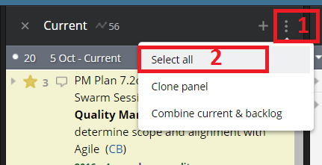

**STEP 2:** Press “CSV” to export the user stories into excel. Do not change the format.

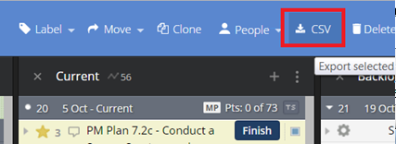

**STEP 3:** Delete all columns that are not needed. The Project Management Office only includes the title, estimate, owner, and tasks for all user stories that are printed for the task board. Format the data as a table.

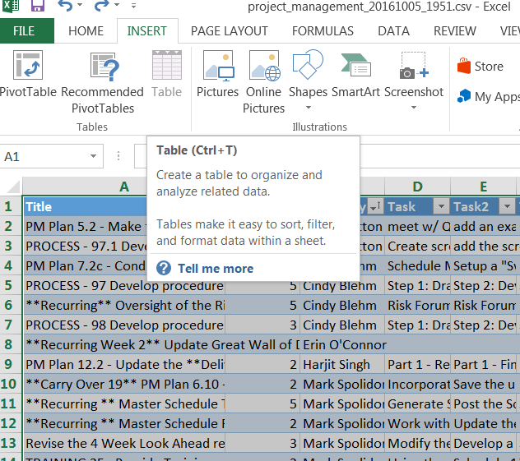

**STEP 4:** Sort the table A to Z using the “Owned By” column, this will group all user stories together for each member of your team.

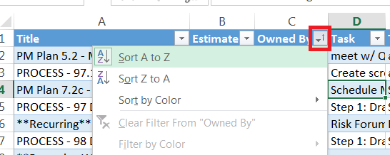

**STEP 5:** Insert blank rows so that you have enough space for each user story task to be on its own row. This will vary from story to story.

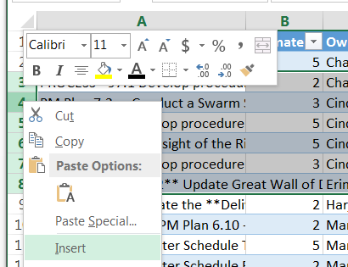

**STEP 6:** Copy the 2nd through the final task of a specific user story, then transpose paste the tasks below the first task. This allows each task to have its own row and its own label on the sprint task board.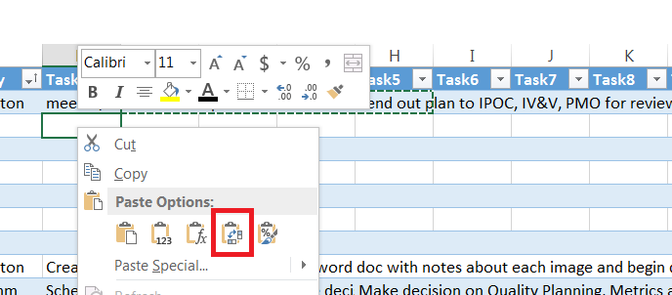

**STEP 7:** After transpose pasting, you can see in the below image that each task has its own row. Next you will want to copy / paste the title, estimate, and owned by data from the 1st task so that each task is associated with the correct story. The example below would need to be pasted 4 times.

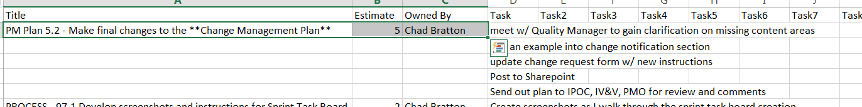

**STEP 8:** After each task is done in excel, delete the extra task columns that are no longer needed and save the file somewhere you will remember. Create a new word doc. Click the mailings tab, then start mail merge, then labels.

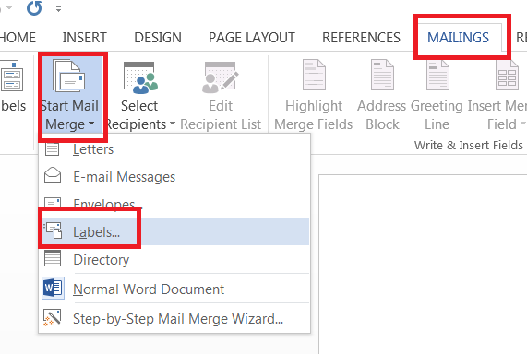

**STEP 9:** Select your label type. The PMO uses standard 5163 shipping labels. Also select the MP printer tray.

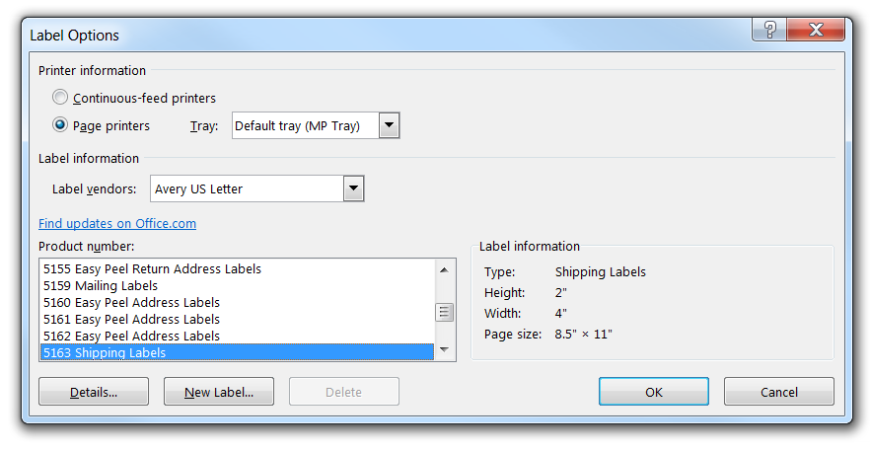

**STEP 10:** Click on “Select Recipients” then click “Use and existing list”. Select the excel file that you just prepared for the labels.

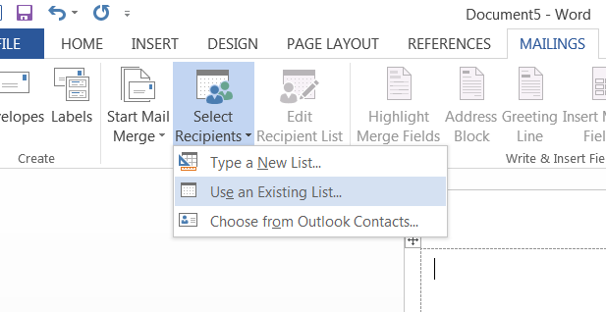

**STEP 11:** Insert Merge Fields one by one for the Title, estimate, Owned By, and Tasks.

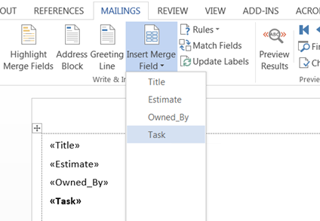

**STEP 12:** Click on “Update Labels” and then “Preview Results”

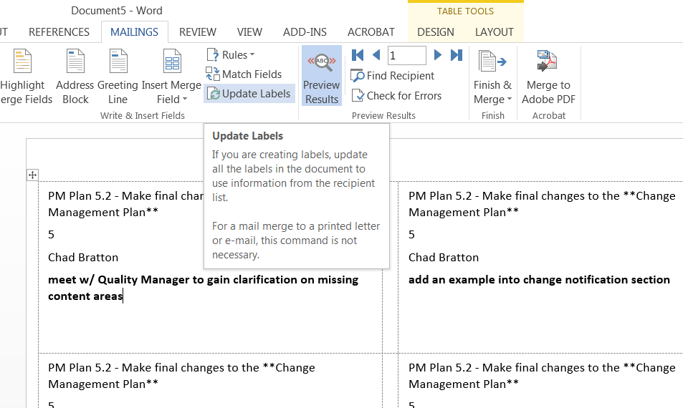

**STEP 13**: If you are ready to print,click on finish and merge > print documents. Select the printer properties and the “paper” tab. Then select “MP Tray” and “Labels” as shown below.

